NBP Analytics System Architecture

Technology Stack
Framework: React 19
Build Tool: Vite
Data Visualization: React Charts
Testing: Jest, React Testing Library
Linting & Formatting: ESLint
Styling: Vanilla CSS

Architectural Pattern
The application follows a Feature-based Architecture with a strict separation between UI components and business logic.
Application Shell: The main entry point that manages the top-level state and renders the selected feature panel.
Features: Contains modules for each major functionality (e.g., Session Trends, Histogram). Each feature is self-contained with its own UI components and CSS.
Core Logic: Contains pure JavaScript modules dedicated to data processing, mathematical calculations, and business logic (e.g., calculating session trends or histogram distributions). This ensures logic is highly testable and decoupled from the UI.
Shared Components: Contains generic, reusable UI elements (e.g., CurrencySelect.jsx) used across multiple features.

System Diagram
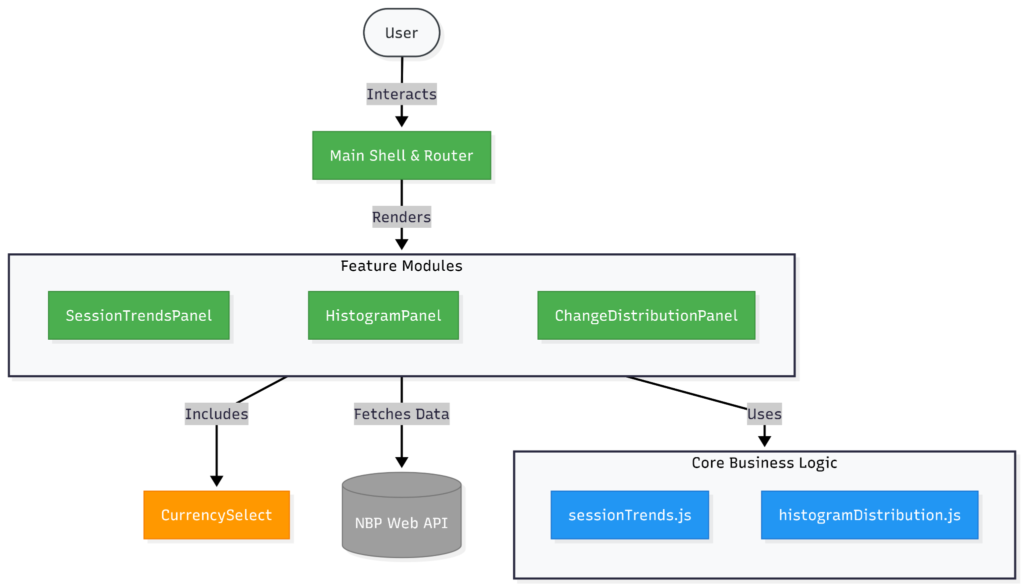

Module Breakdown
src/App.jsx
Acts as the root orchestrator. It holds the global state for navigation and swaps between different feature panels (SessionTrendsPanel, HistogramPanel, etc.) based on the user's selection from the top-level menu.
src/features/
This directory isolates major features into their own folders:
- sessionTrends/: Handles the display of rising, falling, and unchanging trends in currency rates over time.
- histogram/: Visualizes the Monthly and Quarterly Change Distribution of a currency.
- changeDistribution/: A feature module for calculating and displaying specific metric changes.
src/core/
This directory holds the pure data processing algorithms, making it independent of React:
- sessionTrends.js: Analyzes sequences of daily rates to determine bullish, bearish, or stagnant market sessions.
- histogramDistribution.js: Takes raw rate arrays and bins them to produce distribution data suitable for chart rendering.
src/components/
CurrencySelect.jsx: A dropdown component utilized by various feature panels to let the user select which currency to analyze.

Data Flow
User Interaction: The user selects a currency and a time period via a feature panel.
Data Fetching: The feature panel fetches the relevant exchange rates asynchronously from the external NBP API.
Data Processing: Once raw data is received, the feature panel passes it to the appropriate function in the src/core/ directory to parse and transform the raw rates into display-ready metrics
Rendering: The processed metrics are mapped to state, triggering a re-render. The data is visualized using React Charts integrated within the feature panel.

Testing Strategy
UI Tests: Focused on React components using @testing-library/react. Tests user interactions, rendering, and component integration.
Logic Tests: Focused on pure JavaScript functions in src/core/. Ensures mathematical calculations and data transformations are exact and edge-case resilient without needing DOM simulation.

